7.1 System of electrolysis
Name: ____________________ Class: ____________________ Due date: 5.27
1. The diagram shows an incomplete circuit.
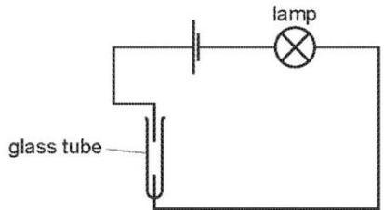
Which substance causes the lamp to light when added to the glass tube? （ ）
A aqueous sodium chloride
B aqueous sugar
C solid sodium chloride
D solid sugar

2. Which substance will not conduct electricity? （ ）
A aluminium B copper C plastic D steel

3.Which statement about electrolysis is correct? （ ）
A Electrons move through the electrolyte from the cathode to the anode.
B Electrons move towards the cathode in the external circuit.
C Negative ions move towards the anode in the external circuit.
D Positive ions move through the electrolyte towards the anode during electrolysis.

4. Which statements about the electrolysis of concentrated copper(II) chloride are correct? （ ）
1 Electrons are transferred from the cathode to the copper(II) ions.
2 Electrons move round the external circuit from the cathode to the anode.
3 Chloride ions are attracted to the anode.
4 Hydroxide ions transfer electrons to the cathode.
A 1 and 3 B 1 and 4 C 2 and 3 D 2 and 4

5. The diagram shows a circuit used to electrolyse aqueous copper(II) sulfate.
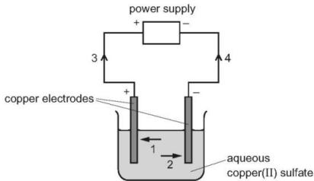
Which arrows indicate the movement of the copper ions in the electrolyte and of the electrons in the external circuit? （ ）
 | copper ions | electrons
A | 1 | 3
B | 1 | 4
C | 2 | 3
D | 2 | 4
6. What will be produced at the anode and at the cathode, if molten potassium chloride is electrolysed? （ ）
 | anode (+) | cathode (-)
A | chlorine | hydrogen
B | chlorine | potassium
C | hydrogen | chlorine
D | potassium | chlorine

7. Which reactions could take place at the anode during electrolysis? （ ）
$$\begin{aligned}&1 4{OH}^{−}(aq)→2H_{2}O(l)+O_{2}(g)+4e^{−} \\ &2 2{Cl}^{−}(aq)→{Cl}_{2}(g)+2e^{−} \\ &3 {Cu}^{2+}(aq)+2e^{−}→Cu(s) \\ &4 2H^{+}(aq)+2e^{−}→H_{2}(g)\end{aligned}$$
A 1 and 2 B 1 and 4 C 2 and 4 D 3 and 4

8. The diagram shows the electrolysis of molten zinc chloride, $ZnCl_{2}$ .
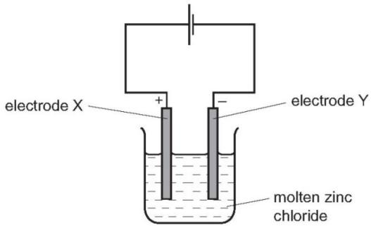
Which statement is correct? （ ）
A Oxidation occurs at electrode X and the equation is: $2Cl^{−}→Cl_{2}+2e^{−}$
B Oxidation occurs at electrode Y and the equation is: $Zn^{2+}+2e^{−}→Zn$
C Reduction occurs at electrode X and the equation is: $Zn^{2+}+2e^{−}→Zn$
D Reduction occurs at electrode Y and the equation is: $2Cl^{−}→Cl_{2}+2e^{−}$

9. What are the electrode products when molten silver iodide is electrolysed between inert electrodes? （ ）
 | cathode | anode
A | hydrogen | iodine
B | iodine | silver
C | silver | iodine
D | silver | oxygen

10. During electrolysis, ions move in the electrolyte and electrons move in the external circuit. Reactions occur at the electrodes.
a.The diagram shows the electrolysis of molten lithium iodide.
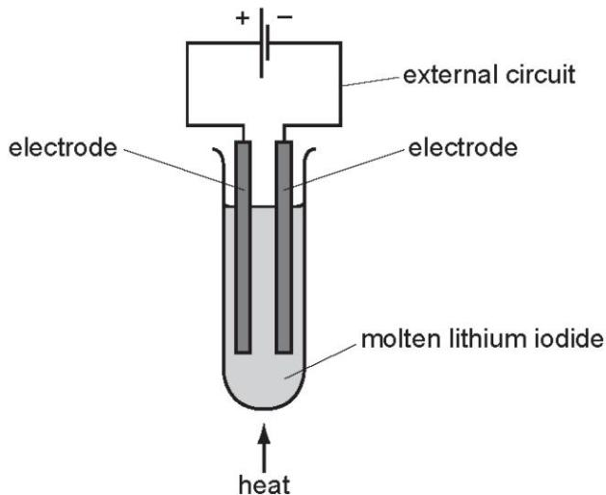
i.Draw an arrow on the diagram to show the direction of the electron flow in the external circuit. [1]

ii.Electrons are supplied to the external circuit. How and where is this done?

iii.Explain why solid lithium iodide does not conduct electricity but when molten it is a good conductor.
[1]

